

AI SEARCH & GAME ALGORITHMS VISUALIZER

A MINI PROJECT (25CAP-612) REPORT SUBMITTED IN PARTIAL FULFILLMENT FOR THE AWARD OF

THE DEGREE OF

MASTERS IN COMPUTER APPLICATIONS

Submitted by
TANUSHRI SAHU (25MCA20366)

Supervisor
Mrs. Ruchika Devi
Professor, UIC

CHANDIGARH UNIVERSITY

UNIVERSITY INSTITUTE OF COMPUTING
CHANDIGARH UNIVERSITY
MOHALI, PUNJAB-140301

TABLE OF CONTENTS
Abstract ............................................................................................................................................ 1
CHAPTER 1. INTRODUCTION ................................................................................................. 2
1.1 Project Overview ....................................................................................................................... 2
1.2 Objective… ............................................................................................................................... 2
1.3 Scope… ..................................................................................................................................... 2 1.4 Tools Used ................................................................................................................................. 2
CHAPTER 2. SYSTEM DESIGN ............................................................................................... 3
2.1 System Architecture… ............................................................................................................... 3
2.2 System Flow ............................................................................................................................. 3
2.3 Data Flow Diagram ................................................................................................................... 3
2.4 Input Output Design .................................................................................................................. 3
2.5 User Interface Design ................................................................................................................ 4
CHAPTER 3. IMPLEMENTATION ......................................................................................... .5
3.1 Implementation Approach…………………………………………………………………….5
3.2 Technologies Used…………………………………………………………………………….5 3.3 Code Implementation………………………………………………………………………….5 CHAPTER 4. TESTING AND OUTPUT……………………………………………………….7
4.1 Objective of Testing……………………………………………………………………………7
4.2 Types of Testing………………………………………………………………………………..7
4.3 Test Results……………………………………………………………………………………..7
4.4 Output Screens………………………………………………………………………………….8
CHAPTER 5. CONCLUSION AND FUTURE WORK………………………………………..11
5.1 Conclusion…………………………………………………………………………………….11
5.2 Future Work……………………………………………………………………………………11
REFERENCES……………………………………………………………………………………..
CHAPTER 6. GITHUB ................................................................................................... ………12

ABSTRACT
The AI Search and Game Algorithms Visualizer is a desktop-based application developed using Python and Tkinter to demonstrate fundamental concepts of Artificial Intelligence through interactive visualization. The primary objective of this project is to help users understand how different AI algorithms operate by providing a graphical interface that visually represents their working process. The project focuses on two important areas of AI: search algorithms and game- playing algorithms.

In the Puzzle Solver module, algorithms such as Breadth First Search (BFS), Depth First Search (DFS), A* Search, and Hill Climbing are implemented on a grid-based environment. These algorithms are used to find a path from a starting point to a goal while avoiding obstacles. The system visually displays the path-finding process, allowing users to observe how each algorithm explores the grid and reaches a solution. Performance metrics such as execution time, number of steps, and nodes explored are also displayed to facilitate comparison.

The Game Playing module consists of a Tic-Tac-Toe game in which a human player competes against an AI. The AI uses Minimax and Alpha-Beta Pruning algorithms to determine the best possible move. These algorithms simulate decision-making in competitive environments and ensure optimal gameplay. The system also compares the performance of these algorithms in terms of execution speed.

The project is implemented using only standard Python libraries, making it simple, portable, and easy to understand. Overall, this project serves as an educational tool for students to visualize and analyze AI algorithms effectively.

.CHAPTER 1

INTRODUCTION

1. Project Overview
The AI Search and Game Algorithms Visualizer is an interactive application designed to demonstrate the working of fundamental Artificial Intelligence algorithms through visual representation. The project focuses on two important areas of AI, namely pathfinding and game playing. In the pathfinding module, also known as the Puzzle Solver, various search algorithms are used to find a path between a start and a goal position in a grid-based environment. In the game-playing module, a Tic-Tac-Toe game is implemented where a human user competes against an AI system. The primary purpose of this project is to help users understand how different algorithms operate internally by observing their step-by- step execution in a visual and interactive manner.

2. Objective
- To implement basic AI search algorithms.
- To visualize algorithm execution step-by-step.
- To compare algorithm performance.
- To implement game AI using Minimax and Alpha-Beta pruning.
- To build an interactive GUI using Tkinter.

3. Scope
The scope of this project is primarily educational, as it is designed to help MCA students understand fundamental concepts of Artificial Intelligence in a practical manner. The system provides a simple platform where users can experiment with different algorithms and observe their behavior visually. Although the current implementation focuses on basic algorithms, the project has the potential to be extended further by incorporating advanced techniques such as Genetic Algorithms, Neural Networks, and other AI-based approaches. It can also be enhanced with improved user interfaces, larger problem environments, and additional features for deeper analysis.

4. Tools Used
- Python – Core programming language
- Tkinter – GUI development
- VS Code / Eclipse – Development environment
- Standard Libraries – time, math, random

CHAPTER 2 SYSTEM DESIGN

2.1 System Architecture
- The system follows a modular architecture consisting of two main modules: Puzzle Solver and Game Playing.
- The User Interface (UI) is built using Tkinter and acts as the interaction layer between the user and the system.
- The Algorithm Module contains implementations of BFS, DFS, A*, Hill Climbing, Minimax, and Alpha-Beta Pruning.
- The Visualization Module handles graphical representation of algorithms using grid and game board.
- The Control Module manages user inputs, algorithm selection, and execution flow.
- The Performance Tracking Module calculates steps, nodes explored, and execution time.
- All modules interact in a structured manner to ensure smooth execution and visualization.

2.2 System Flow
- The user launches the application.
- The main interface is displayed with two options: Puzzle Solver and Game Playing.
- The user selects a module.
- In Puzzle Solver:
  - User selects an algorithm (BFS/DFS/A*/Hill Climbing).
  - User sets start and goal points.
  - User clicks “Start” to begin visualization.
  - The algorithm executes step-by-step and displays results.
- In Game Playing:
  - User selects AI type (Minimax/Alpha-Beta).
  - User plays moves on the Tic-Tac-Toe board.
  - AI responds automatically.
- The system displays results such as path found, winner, steps, and execution time.
- User can compare algorithms using comparison buttons.

2.3 Input Output Design Input Design
- Algorithm selection (BFS, DFS, A*, Hill Climbing, Minimax, Alpha-Beta).
- Grid inputs (start node, goal node, obstacles).
- User moves in Tic-Tac-Toe (mouse clicks).
- Control inputs (Start, Reset, Compare buttons).
- Game mode selection (Human vs AI).

Output Design
- Visual representation of pathfinding (grid with colors).
- Step-by-step animation of algorithm execution.
- Display of shortest path or final result.
- Performance metrics (steps, nodes explored, execution time).
- Game result (Win/Loss/Draw).
- AI decision display and response time.

2.4 User Interface Design
The user interface of the AI Search and Game Algorithms Visualizer is designed to be simple, interactive, and user-friendly so that users can easily understand and interact with the system. The graphical user interface is developed using Tkinter, which provides various widgets such as buttons, labels, frames, and canvas to create an organized layout. The interface is divided into two main sections: the pathfinding visualization module and the game-playing module. In the pathfinding section, users can select algorithms, define start and goal positions, and visualize the step-by-step execution of the algorithm on a grid. Different colors are used to represent visited nodes, obstacles, and the final path, making it easier for users to interpret the process visually.

In the Tic-Tac-Toe module, the interface allows users to play the game against the AI in an intuitive manner. The game board is displayed in a grid format, and users can make moves by clicking on the cells. The AI responds immediately using decision-making algorithms such as Minimax or Alpha-Beta Pruning. The interface also provides feedback such as win, loss, or draw messages, enhancing user engagement. Overall, the design focuses on clarity, ease of use, and effective visualization, ensuring that even beginners can understand the working of AI algorithms without difficulty.

CHAPTER 3 IMPLEMENTATION

1. Implementation Approach
The implementation of the AI Search and Game Algorithms Visualizer follows a structured and modular approach. Initially, the problem requirements were analyzed to identify key functionalities such as algorithm execution, visualization, and user interaction. The system was then divided into two main modules: the Puzzle Solver and the Game Playing module. Each algorithm, including BFS, DFS, A*, Hill Climbing, Minimax, and Alpha-Beta Pruning, was implemented as a separate function to ensure modularity and easy debugging. The graphical user interface was developed using Tkinter, allowing smooth interaction between the user and the system. Step-by-step visualization was achieved by updating the interface dynamically during algorithm execution. Performance metrics such as execution time, steps, and explored nodes were also integrated into the system. The final implementation was tested and refined to ensure accuracy and user-friendliness. 2. Technologies Used
- Python – Main programming language used for implementing algorithms and logic.
- Tkinter – Used for designing the graphical user interface.
- VS Code / Eclipse – Development environment for coding and testing.
- Standard Python Libraries:
- time – For measuring execution time
- random – For generating random elements (if needed)
- math – For heuristic calculations in A* algorithm

3. Code Implementation

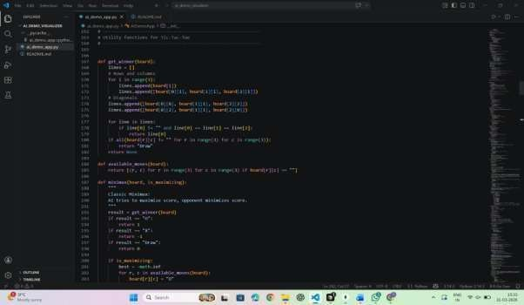

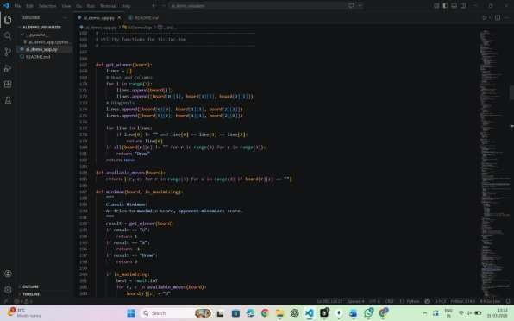

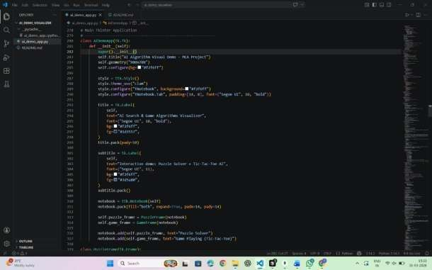

CHAPTER 4 TESTING AND OUTPUT

4.1 Objective of Testing
The objective of testing is to ensure that the system works correctly, efficiently, and without errors. It verifies that all algorithms produce accurate results and that the visualization is displayed properly. Testing also ensures that the user interface responds correctly to inputs and that performance metrics such as execution time and steps are calculated accurately. Additionally, testing helps in identifying bugs and improving the reliability and usability of the system.

4.2 Types of Testing
- Unit Testing – Each algorithm (BFS, DFS, A*, etc.) is tested individually.
- Integration Testing – Interaction between UI and algorithm modules is tested.
- System Testing – Entire application is tested as a complete system.
- Functional Testing – Ensures all features work as expected.
- User Interface Testing – Checks usability and responsiveness of GUI.
- Performance Testing – Measures execution time and efficiency of algorithms.

4.3 Test Results
The system was tested with various inputs and scenarios, and all algorithms performed as expected. The BFS algorithm consistently found the shortest path, while DFS explored deeper paths without guaranteeing optimal results. The A* algorithm showed efficient performance due to its heuristic approach, and Hill Climbing worked well but sometimes got stuck in local optima. In the game module, both Minimax and Alpha-Beta Pruning provided correct AI decisions, with Alpha-Beta performing faster due to pruning. The visualization worked smoothly, and all performance metrics were displayed accurately. Overall, the system passed all test cases successfully.
Output Screens

Puzzle solver
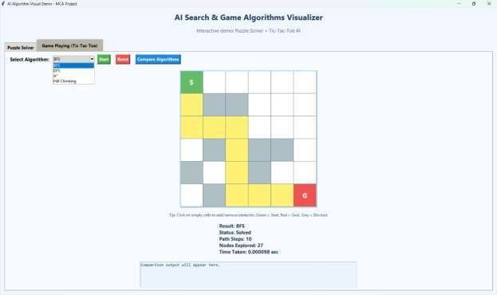

Compare Algorithms
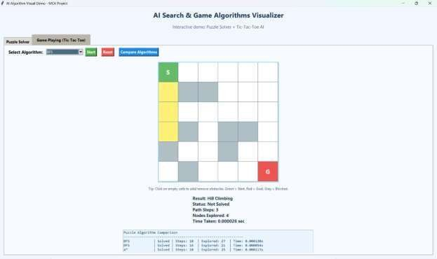

Tic-Tac-Toe
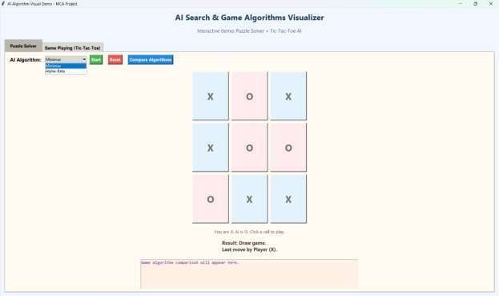

Compare Algorithms
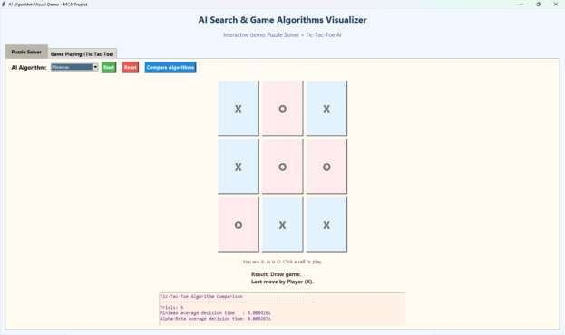

CHAPTER 5 CONCLUSION AND FUTURE WORK

5.1 Conclusion
This project successfully demonstrates the practical implementation and visualization of fundamental Artificial Intelligence algorithms in an interactive and user-friendly manner. By integrating pathfinding algorithms such as BFS, DFS, A*, and Hill Climbing with game-playing algorithms like Minimax and Alpha-Beta Pruning, the system provides a clear understanding of how different AI techniques work in real-time scenarios. The Puzzle Solver module effectively shows how search algorithms explore paths and find solutions, while the Tic-Tac-Toe module highlights decision-making strategies used in game AI.
The graphical interface developed using Tkinter enhances user experience by allowing easy interaction, visualization, and comparison of algorithm performance. The project also helps in analyzing key factors such as execution time, number of steps, and efficiency of algorithms. From the results, it is evident that heuristic-based algorithms like A* and optimization techniques like Alpha-Beta Pruning provide better performance compared to basic approaches.

Overall, this project serves as an effective educational tool for students to understand AI concepts in a practical way. It bridges the gap between theoretical knowledge and real- world implementation. Although the project is limited to basic algorithms and small-scale problems, it lays a strong foundation for further development in advanced AI fields such as machine learning, robotics, and intelligent systems.
5.2 Future Work o The project can be extended by adding advanced AI algorithms such as Genetic Algorithms and Neural Networks. o A more advanced and attractive user interface can be developed using modern frameworks.
- The system can be converted into a web-based application for better accessibility.
- More games such as Chess or Sudoku can be added for advanced AI implementation.
- Database integration can be added to store user data and performance history. o Real-time analytics and graphical performance comparison can be included.

REFERENCES
- Stuart Russell and Peter Norvig, Artificial Intelligence: A Modern Approach.
- Python Official Documentation – https://docs.python.org
- Tkinter Documentation – https://docs.python.org/3/library/tkinter.html
- GeeksforGeeks – https://www.geeksforgeeks.org
- TutorialsPoint – https://www.tutorialspoint.com
- Lecture notes and study materials (MCA curriculum).

6. Github 1. Screenshot

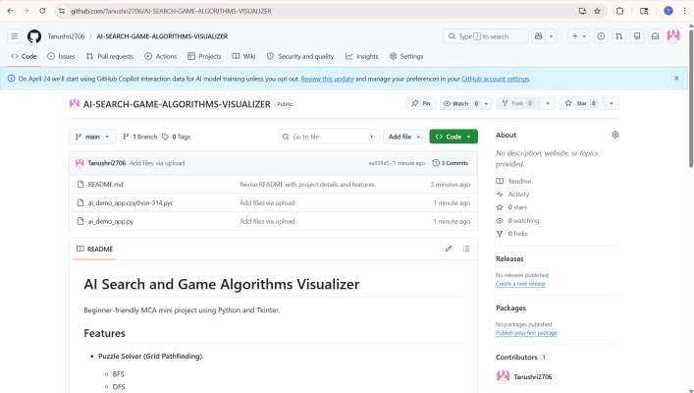

2. Github Link- https://github.com/Tanushri2706/AI-SEARCH-GAME-ALGORITHMS-VISUALIZER

